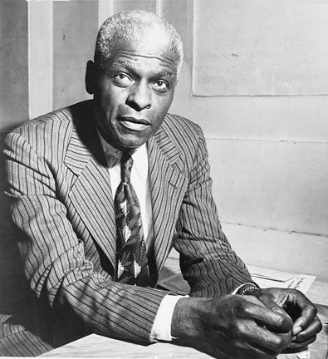
Tuesday, February 10, 2015: BHP #6: Benjamin Mays

- What does Mays have in common with another person we’ve profiled?
- What two ideas are described as Mays’ “unwavering emphasis?”

Then, answer the question posed at the top of column three: Why does the Georgia Department of Education require students to learn about this person? In other words, how is the story inspiring, unique, or instructive?

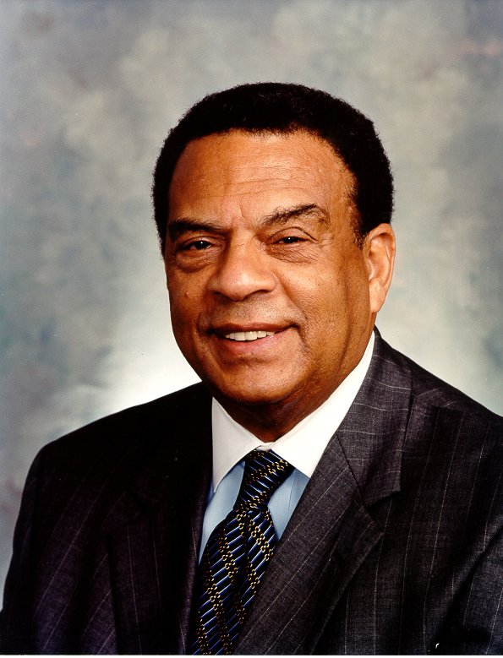
Wednesday, February 11, 2015: BHP#7: Andrew Young

- Explain Young’s involvement with the SCLC.
- What political offices did Young hold?
- How did Young “transform the basis of American foreign policy?”

Then, answer the question posed at the top of column three: Why does the Georgia Department of Education require students to learn about this person? In other words, how is his story inspiring, unique, or instructive?
ALL CLASSES: PICK UP THE READING TITLED “The Reconstruction Period”
3rd, 5th, and 6th: PICK UP SHARECROPPER’S CYCLE OF POVERTY GLUE ON A NEW PAGE. LEAVE ROOM FOR A T-CHART

Wednesday, February 18, 2015: BHP#8: Maynard Jackson
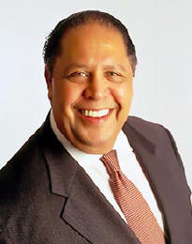
- Why is Jackson’s term as Mayor notable?
- List Jackson’s achievements as Mayor of Atlanta.

Then, answer the question posed at the top of column three: Why does the Georgia Department of Education require students to learn about this person? In other words, how is his story inspiring, unique, or instructive?

Tuesday, February 24, 2015: BHP #9: Charlayne Hunter and Hamilton Holmes

- How did UGA officials initially exclude Holmes and Hunter from enrolling?
- What was Judge Bootle’s ruling and his reasoning?
- What was the reaction to Bootle’s decision?
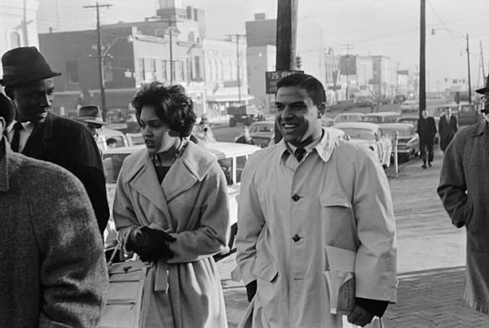
- How did Holmes and Hunter go on to contribute to society?

Then, answer the question posed at the top of column three: Why does the Georgia Department of Education require students to learn about these people? In other words, how is the story inspiring, unique, or instructive?

