Monday, February 2, 2015
Black History Month Profile #1-Alonzo Herndon

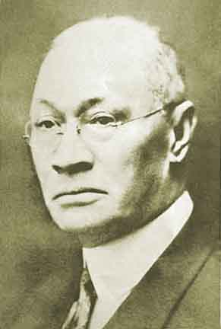
Complete the following thought in the “Focus Question” Column of the response sheet:

Alonzo Herndon created personal wealth by…

Then, answer the question posed at the top of column three: Why does the Georgia Department of Education require students to learn about this person? In other words, how is his story inspiring, unique, or instructive?

Turn in your 1864-Aftermath Reports

Wednesday, February 4, 2015
Black History Month Profile #2: Booker T. Washington
USE THE READING DATED FEBRUARY 3
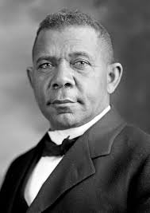
Focus Question:
1. Why did apprehensive white people invite Washington to speak?
2. Why would Washington’s message be disappointing to some blacks?

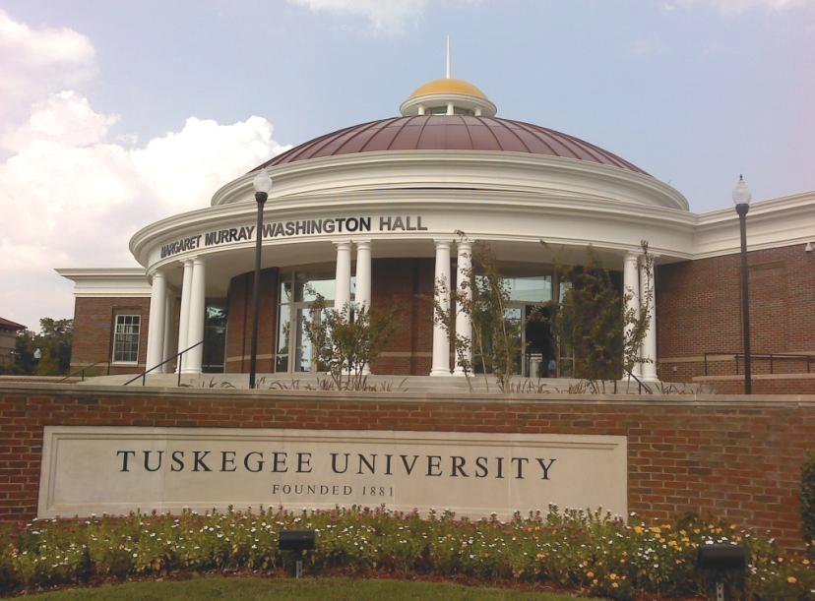
Then, answer the question posed at the top of column three: Why does the Georgia Department of Education require students to learn about this person? In other words, how is his story inspiring, unique, or instructive?

Thursday, February 5, 2015
Black History Month Profile #3: W.E.B. DuBois
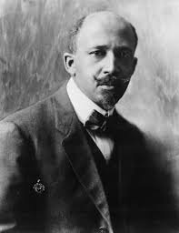
Focus Question: Briefly describe the “dispute” between Booker T. Washington and Du Bois.
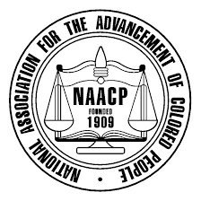
Then, answer the question posed at the top of column three: Why does the Georgia Department of Education require students to learn about this person? In other words, how is his story inspiring, unique, or instructive?

Ms. Fielder needs to see:
Gwyneth S., Kimberly, Malachi, Leslie, Nicole, Thomas C., Harris W., Rishab, Sparks, Jack Y., Isaiah, Maria, Ethan R., Sadie, Kathleen, Kyle, Samara, Liana, Haley, Zen, Emily T.

Friday, February 6, 2015
Black History Month Profile #4: Lugenia Burns Hope
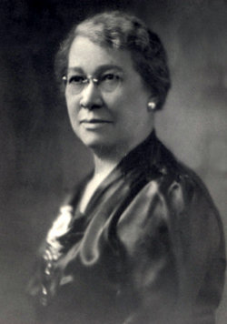
Focus Questions:
1. List 4 of Mrs. Hope’s social reforms.
2. How did the Neighborhood Union help communities?
3. What were citizenship schools?

Then, answer the question posed at the top of column three: Why does the Georgia Department of Education require students to learn about this person? In other words, how is his story inspiring, unique, or instructive?

Monday, February 9, 2015
Black History Month Profile #5: John Hope
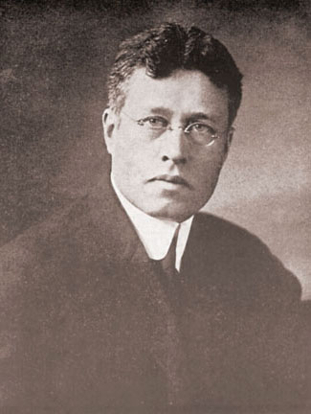
Focus Questions:
1. How did Hope improve Morehouse College? What was his title?
2. What did Hope have in common with Du Bois?
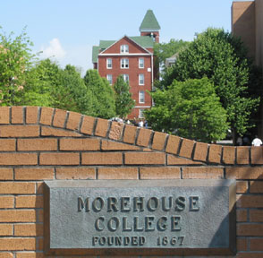
Then, answer the question posed at the top of column three: Why does the Georgia Department of Education require students to learn about this person? In other words, how is his story inspiring, unique, or instructive?

