The New South
Class Notes and Readings for Speech Preparation

Directions: Formulate a system for classifying information as economic, social, and/or political forces.
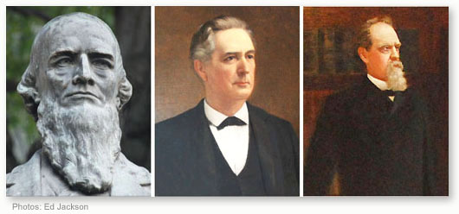
Part I: The Bourbon Triumvirate
This term refers to three politicians: Joseph E. Brown, Alfred Colquitt, and John B. Gordon. These three people were the most powerful and influential politicians in Georgia during the post-Reconstruction period. All three liked Henry Grady’s “New South”. They also supported the expansion of railroads and industry, white supremacy, and oppressive labor systems. Gordon and Brown both used convict labor. All three politicians believed government should not spend much money which means that the government did not provide many services. The three men disagreed over tariffs and later, over convict lease reform. Many historians dispute the idea that they worked together harmoniously, but they had unprecedented power in the state during the post-Reconstruction years.
Offices Held:
Brown: Senator (1880-1890) Colquitt: Governor (1876-1882) and Senator (1883-1894)
Gordon: Senator (1872-1880, 1891-1897) and Governor (1886-1890)
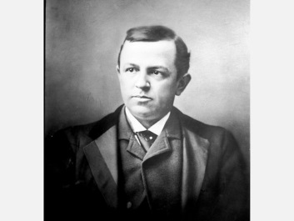
Part II: Henry Grady
One reason why the Bourbon Triumvirate was able to hang on to power is because of the support of Henry Grady. Grady was a graduate of the University of Georgia and a journalist who was the managing editor of the Atlanta Constitution. Grady first gained notoriety when he published an article entitled “The New South”. Grady’s article advocated industrial development and diversified agriculture as a cure to the south’s post-war economic struggles. He traveled throughout the north giving speeches, organized “cotton expositions” to attract tourism and investors, and lobbied for a school devoted to industrial education which became Georgia Tech. Politically, Grady’s newspapers served as propaganda for the “Atlanta Ring” of politicians that included Brown, Gordon, and Colquitt. With a circulation of over 120,000, the newspaper was a key electoral tool. Even though Grady’s “New South” was popular with many people, it did have its critics. First of all, farmers believed the northern influence would hurt them. Second, Grady was a proponent of the white supremacist racial order in the south and claimed that the region had a favorable climate for blacks despite its record of violence and segregation.

Grady was known as being humorus, witty, and favorable to audiences. He often used stories rather than statistics to explain his points. For example:
Henry Grady to the Bay State Club of Boston, 1889
I attended a funeral once in Pickens county in my State. . . . This funeral was peculiarly sad. It was a poor “one gallus” fellow, whose breeches struck him under the armpits and hit him at the other end about the knee—he didn’t believe in decollete clothes. They buried him in the midst of a marble quarry: they cut through solid marble to make his grave; and yet a little tombstone they put above him was from Vermont. They buried him in the heart of a pine forest, and yet the pine coffin was imported from Cincinnati. They buried him within touch of an iron mine, and yet the nails in his coffin and the iron in the shovel that dug his grave were imported from Pittsburg. They buried him by the side of the best sheep-grazing country on the earth, and yet the wool in the coffin bands and the coffin bands themselves were brought from the North. The South didn’t furnish a thing on earth for that funeral but the corpse and the hole in the ground. There they put him away and the clods rattled down on his coffin, and they buried him in a New York coat and a Boston pair of shoes and a pair of breeches from Chicago and a shirt from Cincinnati, leaving him nothing to carry into the next world with him to remind him of the country in which he lived, and for which he fought for four years, but the chill of blood in his veins and the marrow in his bones.

Part III: Voting
Key terms:
Suffrage-the right to vote
Enfranchisement-to give the right to vote
Disenfranchisement-the denial of the right to vote

Even thought the Fifteenth Amendment guaranteed the right to vote regardless of
race, color, or previous condition of servitude, southern states passed laws to
circumvent this amendment. One law required the payment of a poll tax and others
required literacy tests. Grandfather clauses stated that if a voter’s grandfather had the right to vote, then he had the right to vote as well. Since southern blacks most likely had grandfathers who were slaves, they were excluded from voting. The grandfather clause also ensured that poor and/or illiterate white men could vote. Many southern states, including Georgia, also held whites-only primaries. The Supreme Court upheld the use of these primaries with the reasoning that political parties were private organizations and could make their own rules.

Another way Democrats were sure to keep political power was through the county-unit system. The system divided counties into three groups: urban, town, and rural. A primary is an election to determine who will run for a statewide or national political office.

Example: There are three candidates who want to run for the Democratic nomination for Governor. The three candidates run against one another in the Democratic Primary. The winner will face the Republican candidate in the statewide election. Since most Georgia voters were Democrats, the winner of the primary was probably going to win the office.

Urban Counties: 6 Unit Votes Town Counties: 4 Unit Votes Rural Counties: 2 Unit Votes
If a candidate got the plurality of votes in a county, that candidate would get all of the unit votes.

Problem: Rural counties had an inordinate amount of power.
Example:
The population of Fulton County in 1880 was 556, 326 (urban/6 units)
The population of Echols County was 2, 553 (rural/2 units)
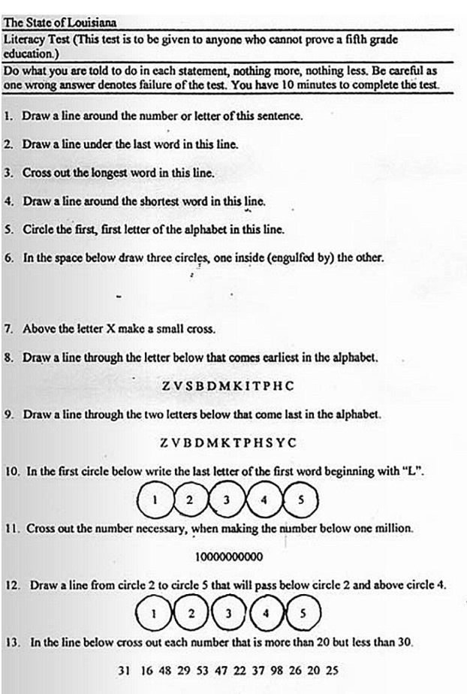
So…in Fulton County, one unit represented over 90,000 voters. In Echols County, one unit represented just over 1,000 voters.

The county-unit system effectively reduced the power of the more populated cities who were likely to nominate candidates who represented radical interests.

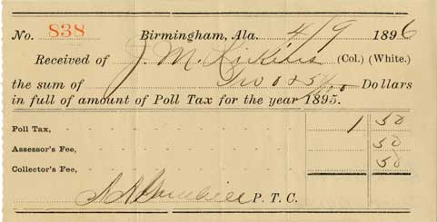

Part IV: Jim Crow Laws
From http://www.ferris.edu/news/jimcrow/what.htm:
Jim Crow was the name of the racial caste system which operated primarily, but not exclusively in southern and border states, between 1877 and the mid-1960s. Jim Crow was more than a series of rigid anti-black laws. It was a way of life. Under Jim Crow, African Americans were relegated to the status of second class citizens. Jim Crow represented the legitimization of anti-black racism. Many Christian ministers and theologians taught that whites were the Chosen people, blacks were cursed to be servants, and God supported racial segregation

Examples:
- Prisons. The warden shall see that the white convicts shall have separate apartments for both eating and sleeping from the negro convicts (Mississippi).
- Reform Schools. The children of white and colored races committed to the houses of reform shall be kept entirely separate from each other (Kentucky).
- Teaching. Any instructor who shall teach in any school, college or institution where members of the white and colored race are received and enrolled as pupils for instruction shall be deemed guilty of a misdemeanor, and upon conviction thereof, shall be fined... (Oklahoma).
- Wine and Beer. All persons licensed to conduct the business of selling beer or wine...shall serve either white people exclusively or colored people exclusively and shall not sell to the two races within the same room at any time (Georgia).

**Racial segregation was upheld by the Supreme Court in 1896. In Plessy vs. Ferguson, the Court held that “separate but equal” facilities were Constitutional. This ruling would not be overturned until 1954.

Jim Crow Etiquette:

- A black male could not offer his hand (to shake hands) with a white male because it implied being socially equal.
- Blacks and whites were not supposed to eat together. If they did eat together, whites were to be served first, and some sort of partition was to be placed between them.
- Under no circumstance was a black male to offer to light the cigarette of a white female -- that gesture implied intimacy.
- Jim Crow etiquette prescribed that blacks were introduced to whites, never whites to blacks. For example: "Mr. Peters (the white person), this is Charlie (the black person), that I spoke to you about."
- Whites did not use courtesy titles of respect when referring to blacks, for example, Mr., Mrs., Miss., Sir, or Ma'am. Instead, blacks were called by their first names. Blacks had to use courtesy titles when referring to whites, and were not allowed to call them by their first names.
- If a black person rode in a car driven by a white person, the black person sat in the back seat, or the back of a truck.
- White motorists had the right-of-way at all intersections.

Part V: New South Economics
Source:https://www.georgiastandards.org/Frameworks/GSO%20Frameworks%20Support%20Docs/Instructional-Guide-Grade-8-Georgia's-Economy.pdf

During the New South period, the Bourbon Redeemers and Henry Grady encouraged new
industry and farming practices. Grady’s speeches and editorials generated a level of optimism to
the people of Georgia. Northern investors built mills in state because of the mild climate, low
taxes and cheap labor. In 1881, Georgia hosted the first of three cotton exhibitions highlighting
the cotton industry and economic opportunity for northern investors. A granite quarry from
Elberton also displayed the first granite headstone and business generated by that showing led
to the city’s nickname, “The Granite Capital of the World”. By 1890 there were nearly 100
textile mills in operation in Georgia.
In addition to the continued dependence on “King Cotton”, a new industry emerged — the naval
stores. Naval stores are products from pine trees (turpentine, rosin, lumber) that are used in
the repair and maintenance of ships. Originally based in North Carolina, naval store producers
came to the sparsely populated coast of Georgia to make use of the pine trees. By 1890,
Georgia was the leading producer of naval stores. Some freed slaves left the fields for the
forests to be employed by the naval store producers.
In addition to agriculture and new agriculturally based industries during this time period, there
were new products and companies that called Georgia home. Coca-Cola, invented in 1886, was an
alternative to alcohol and gained popularity during the temperance movement. Atlanta Life
Insurance Company was started by former slave turned entrepreneur, Alonzo Herndon, in
1905.
Despite the advancements, most of Georgia’s farm acreage was occupied by sharecroppers and tenant farmers. The lives of these landless citizens were difficult to escape. Sharecroppers were, in most cases, victims of reenslavement, lived in shacks, and did not have the luxuries of electricity, running water, mail delivery, or nearby schools.

Part VI: Violence
After the Redeemers regained control of Georgia politics and President Cleveland removed federal troops, the influence of the Ku Klux Klan faded. In 1915, a movie entitled The Birth of a Nation showed the founding of the KKK as a heroic event in American history. The group, according to the movie, restored order and honor to the post-war south. The film is credited with sparking the formation of the “Second Klan” at Stone Mountain, Georgia. This Klan’s platform was anti-Semitic, anti-Catholic, anti-immigrant, and prohibitionist.

From Our Georgia History:
Atlanta turned out in force to watch the lynching of Sam Hose (Wilkes), a itinerant black worker who admitted killing wealthy Alfred Cranford, a resident of the rural town of Newnan.
Born in Macon, Hose had moved to Atlanta and then Newnan in search of work. Here he found employment with Alfred Cranford a wealthy local white resident. As the story goes after more than a year a dispute arose over money owed to Hose by Cranford. Cranford secured a gun, became enraged at Mr. Hose and threatened him. Hose took an ax and threw it at Cranford and ran. Papers blared the details of the "murder," and the area was combed looking for Sam Hose. By his own admission, Hose knew he had hit Cranford with the ax but did not know he had killed the man until several days later. Then came the charge of rape. Then a story came out that Mrs. Cranford claimed that her husband's assailant had raped her as her husband lay dying.
A $500 reward was posted and Hose was captured on the night of Saturday, April 22. According to Ida Wells, who championed the case, newspapers including the Atlanta Constitution had hinted that Hose would be torture before being lynched or burned. What happened was unspeakable. Two trainloads of Atlantans (according the Constitution) arrived to witness Hose being burned alive. He was mutilated (fingers, hands, and ears severed, flesh on his face skinned off), tied to a tree and burned. Parts of his body were taken by onlookers.

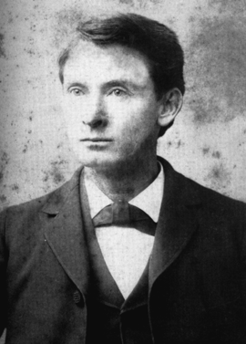
Part VI: Tom Watson and Rebecca Latimer Felton

Tom Watson was a lawyer, politician, and journalist who is, perhaps, one of the most mystifying people in Georgia’s post-Reconstruction history. Watson began his political career as the leader of the Populists, a political party who advocated laws against lynching, aid to farmers of both races, taxes to support public education, and the enfranchisement of blacks (probably because he needed their votes). Watson opposed industrial development, favoring instead an idyllic agrarian economy.

Sounds like a great guy, right?

Since Watson had many rural supporters, both white and black, his endorsement was important for any political candidate and he had significant influence even though he did not consistently hold political office.

By 1904, Tom Watson changed his stance on most issues. He opposed leaders like Booker T. Washington. He no longer advocated enfranchisement and political inclusion of blacks. He wrote vicious editorials against blacks, the Catholic Church, and Judaism. He continued to support farmers who were the victims of industry, and on that support he was elected to the U.S. Senate in 1920 but died two years into his term. Watson’s statue was removed from the grounds of the Georgia Capitol in 2013.

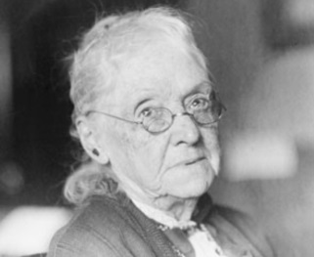
Rebecca Latimer Felton rose to prominence by managing her husband’s campaigns and terms as U.S. Representative and Georgia Assemblyman. After her husband’s returement, she advocated for reforms through speeches and writings. She fought against the convict lease system, supported public schools for girls, and advocated for women’s suffrage. Despite these noble aims, Felton had conservative racial views and lashed out at anyone who questioned the south’s racial policies.

Felton is known as the first female U.S. Senator. When Tom Watson died, she was appointed to his seat until a special election could be held. Felton officially served one day in office after being sworn in. Rebecca Felton was, in some ways, very progressive-minded, but in other ways was a product of her time and place.

