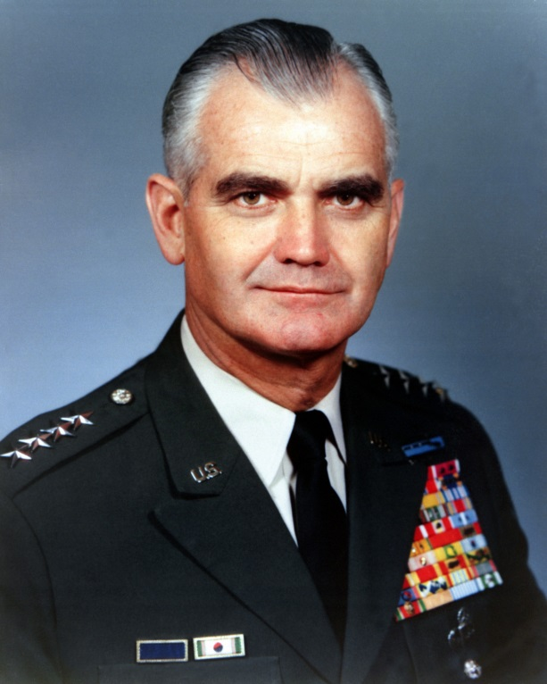

General William Westmoreland commanded United States troops in Vietnam from 1964-1968. In the 1974 documentary Hearts and Minds, Gen. Westmoreland described the Vietnamese as inferior and incapable of human emotions such as a parent’s attachment to a child. Westmoreland is believed to have tacitly authorized what are now considered by some to be war crimes during the Vietnam War.
http://en.wikipedia.org/wiki/William_Westmoreland

Hearts and Minds, directed by Peter Davis (1974: Los Angeles, CA: BBS Productions).

